First International Course on Field Geoarchaeology from Northwest Argentina
GEOARCHAEOLOGY FROM CALCHAQUÍES VALLEYS
Dates: 4 – 6 August 2016

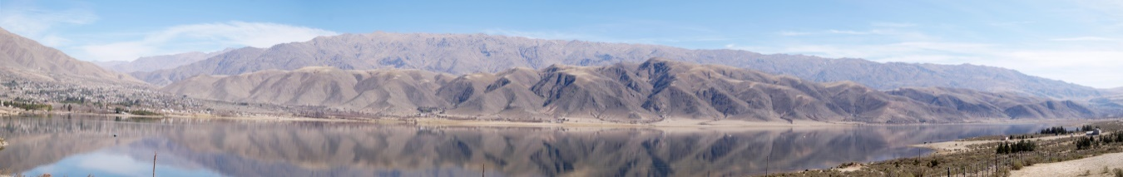
PREINSCRIPTION FORM
Name
e-mail
Institution
Interests
Position

Sponsored by:
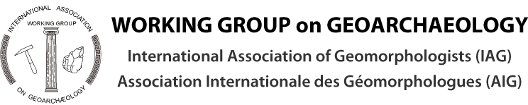
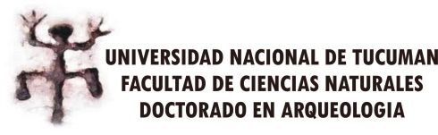
http://www.radiocarbon.com/espanol/index.htm
For further information please contact: Dr. M. M. Sampietro - sampietro@tucbbs.com.ar

